***The Software Design Specification Outline***

1. **Introduction**

This project is web-based system. Online stadium ticket reservation system is basically made for providing the customers with adequate service, anywhere and anytime. This system creates a huge relief for the football fans. This system provides help to the user as they can inquire about seat, its ticket price, available seats, about upcoming events, date and time as well etc. They don’t need to walk to the stadium for their reservation purpose. For building this software properly we need some design specification. In SDS we are discussing those which are given below.

**1.1Purpose of this document**

Before starting this task we have selected some purposes .And we have a goal, objective and motivation.The main objective of this SDS document is to understand and illustrate to the general public about this software.We have prepared a software design specification so that people can easily understand about using of this software.Here we will use HTML, CSS,PHP,Java Script and so on.We have also use Laravel as a frame work.The language we will use to build our software which is very popular to us now a days.We think that those languages are able to make an excellent software which will encourage the general people to utilize this software.

**1.2 Scope of the development project**

In our project we will use some languages like HTML,CSS,PHP,JAVA SCRIPT etc. Here’s are some description about those:

**HTML** :The Hypertext Markup Language is used for describing the structure and it is presented of information via the Internet HTML are displayed on the World Wide Web.

**CSS :** is used for describing the presentation of Web pages, including colors, layout, and fonts. It can defines large screens, small screens, or printers. **CSS** is independent of HTML .

**PHP:**  is a general-**purpose** scripting language that is especially suited to server-side web development, in which case **PHP** generally runs on a web server.

**JavaScript:**  is a CS (Client Side) scripting language. It is in no way related to Java as it's name suggests, but it is used for client side scripting. By Client Side scripting, i mean the ability to manipulate data

We will use those languages because those languages are totally perfect to make a successful project. Those are used for making a colorful ,easy and understandable website so that public can easily use this website. If it might easy to use and interesting we think that it will enlarge the stadium business.

**1.3 Definitions, acronyms, and abbreviations**

Be sure to alphabetize!

**1.4 References**

[1].Lars Mathiassen et.al 2000. Object oriented analysis & design. Marko, Aalborg. Dk .

[2].Wendy Chisholm, Gregg Vanderheiden & Ian Jacobs, 1999, Web Content Accessibility Guildlines 1.0, /http://www.w3.org/TR/WAI-WEBCONTENT/ (Date Accessed: 14/02/06).

[3].Matt May-W3C, 2005,Inaccessibility of CAPTCHA /http://www.w3.org/TR/turingtest/(DateAccess:21/03/06)

[4].Luke Welling and Laura Thomson, 2005, PHP and MySQL Web Development, Sams Publishing, United States of America

[5].Jakob Nielsen, 2000, Designing Web Usability: The Practice of Simplicity, 2000, New Riders Publishing, United States of America.

[6].H. M. Deitel, P. J. Deitel & Tem. R. Nieto, 2002, Internet & World Wide Web How to Program, Pearson Education

– Prentice Hall, United States of America.

[7].Oloyede Alaya, Adewole, "Developmentof an Online Bus

Ticket Reservation System for a Transportation Service in Nigeria", Computer Engineering and Intelligent Systems, vol. 5, no. 12,2014, ISSN 2222-2863.

[8].Vijethas shetty, "E-Ticketing in India - A Study on the

Indian Railway Catering & Tourism CorporationLtd", 2014.

[9].Antero Juntunen, Sakari Luukkainen, "Deploying NFC

Technology for Mobile Ticketing Services", 2010.

[10].Center for Railway Information System, Passenger Reservation System. http://cris.org.in/CRIS/Projects/PRS.

5

**1.5 Overview of document**

**1. User**

This Project is basically provides a Stadium reservation system and regarding next event information. First of all, in our website any user or visitor can view our system .User shall able to log-in and register its own seat in this website, user can easily know about the upcoming event, date and time .They can book their ticket, cancel and can print the ticket as well. But user can compulsory registered first in the system.

**2.Admin**

In this system admin can maintain all the event information and comments etc. In this system admin can maintain the registered users , manage news ,and also admin can generates a reports and manage the whole system .Admin also can add event and changes event schedule as well.

**Admin Home Page**

**a. Login** Login Module includes various utilities like User Authentication, Change Password and Forgot Password.

**User Login Page**

**b. Registration** In this website provide a some facility user can registered in this website. User can use this facility so user can make a registration.

**Signup Page**

**C .**Book the Ticket In this project, User can able to buy their available seat to justify their own sense.

**Booking Sucessful Page**

Update event Information In this module, admin can add or Update an event as well. It contains the information about the event type , seat photo, description, Location , Available Seats in the stadium etc.

**Home Page**

**d.** Cancel the Booking Ticket In this Module, User can Cancel the booking Ticket.

**e.** Find the booking seat Further time, user can check or find their booking seat for remove their confusion in this website.

**g.** Cancel the Event

In this project, admin also can cancel an event as well.

**2.Architecture**

Here’s the overall design of our project for better understanding.

**Software Development paradigm**

For completing this software we have to go ahead step by step. First of all we will have some requirements. Then we will do some design .By following this design we have to implement the whole software. After completing those three task we will have to verify the whole thing that is it ok or not. Then we have to maintain it like we have to spread it into corporate world or in the another side.

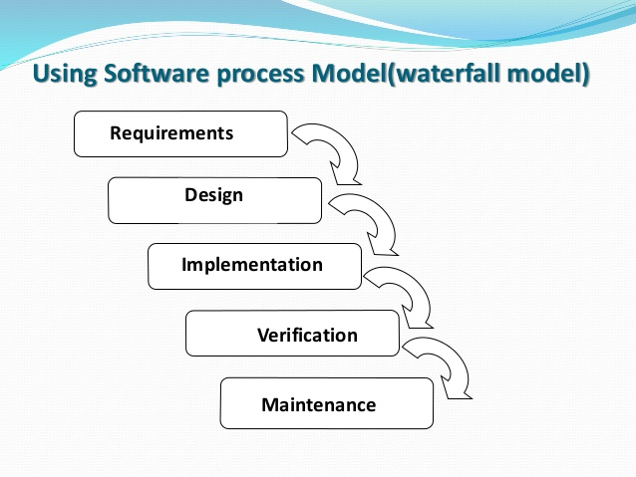

**ER Diagram:**

It’s an essential part before completing a successful website.ER diagram shows us the way that what will be the criteria of this website.Here we have Entity sets ,relationship between two entities,and attributes as well. The diagram which is shown below here admin ,user info,game info and the ticket info are the entities.There is a relationship among all the entities.And they have some attributes as well.

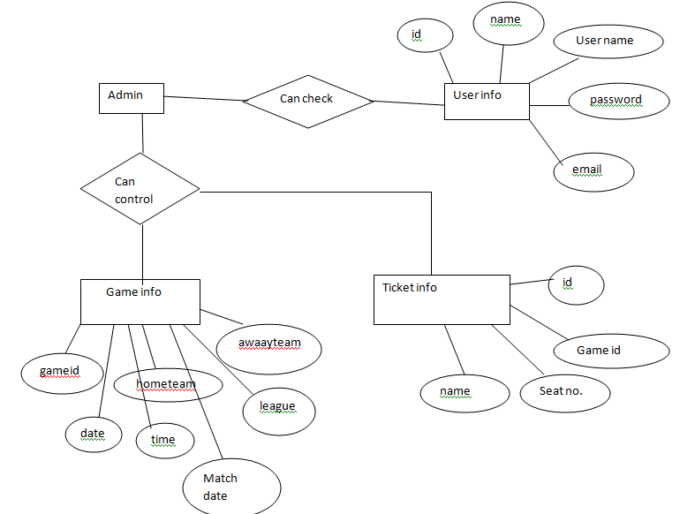

**3. Component Design Specification(s)**

In our project we will use some languages like HTML,CSS,PHP,JAVA SCRIPT etc. Here’s are some description about those:

**HTML** :The Hypertext Markup Language is used for describing the structure and it is presented of information via the Internet HTML are displayed on the World Wide Web.

**CSS :** is used for describing the presentation of Web pages, including colors, layout, and fonts. It can defines large screens, small screens, or printers. **CSS** is independent of HTML .

**PHP:**  is a general-**purpose** scripting language that is especially suited to server-side web development, in which case **PHP** generally runs on a web server.

**JavaScript:**  is a CS (Client Side) scripting language. It is in no way related to Java as it's name suggests, but it is used for client side scripting. By Client Side scripting, i mean the ability to manipulate data

We will use those languages because those languages are totally perfect to make a successful project. Those are used for making a colorful ,easy and understandable website so that public can easily use this website. If it might easy to use and interesting we think that it will enlarge the stadium business.

**4. User interface issues**

1) It allows user to view quick chart like match schedules, current match lists, he can also see the booked tickets.

2)It provides a search facility based on different sport like football, cricket.

3)The user interface must be customizable by the administrator.

4)The user interface should be able to interact with the user management module and a part of the interface must be dedicated to the login/logout module.

.**5. Execution Architecture**

For completing this software we have to go ahead step by step. First of all we will have some requirements. Then we will do some design .By following this design we have to implement the whole software. After completing those three task we will have to verify the whole thing that is it ok or not. Then we have to maintain it like we have to spread it into corporate world or in the another side.

To build this software we have drawn an ER diagram. In this ER diagram we have entity sets like admin, user, ticket info, game info etc. We have attributes as well .After drawn this diagram it will easy to make our software easily. We will run this software by using Xampp and Subline text.

**6. Design decisions and tradeoffs**

Use this section to motivate any decisions that will help the reader understand

the design that your team is using. This section can also capture good ideas

that were abandoned and the reasons for leaving them out of the design.